Points to be Covered in Linux Assignment-1
- Explain CLI & GUI
- Login Terminals
- Explain Files & Directory
- Basic Commands
  - ls, cd, mkdir, rm, man, touch, cp, mv, less, more, head, tail, grep with options.
- File Editors
  - vi, vim, nano, gedit.
- Links o Softlink & Hardlink.
- Paths o Absolute Path & Relative Path.
- Redirections o I/O Redirection Operators.(>, >>, &> , &>>)

Assignment-1 Questions:
(Note: All answers should include an attached screenshot as proof of execution)

- What does CLI stand for, and how does it differ from GUI?
ASPECT CLI GUI
Interaction Text-based, commands typed manually. Visual, uses icons and buttons.
Ease of Use Complex, suitable for advanced users. Simple, user-friendly for beginners.
Performance Faster, lightweight. Slower, resource-intensive.
Flexibility Highly customizable, supports scripting. Limited to predefined options.

- Open a terminal and execute a simple command such as echo "Hello". Can you perform a similar action in a GUI? What are the advantages of using a CLI compared to a GUI?
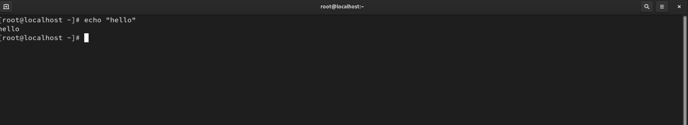

The advantages of CLI over GUI include faster execution for repetitive tasks, automation through scripting, less resource consumption, and more precise control over system function.

- To convert a minimal CLI-based Linux interface into a GUI-based one, which packages are typically required? Find them
To convert a CLI-based Linux interface into a GUI-based one, you typically need to install:
. X Window System (Xorg) – Provides the graphical display server.
. Desktop Environment – Examples include GNOME, KDE Plasma, XFCE, or LXDE.
. Display Manager – Manages user logins, e.g., GDM, LightDM, or SDDM.

- What are terminals in Linux? How many virtual terminals are available on your system, and which key combination is used to access them?
Terminals in Linux are interfaces that allow users to interact with the system using commands. Most Linux systems provide 6 virtual terminals (accessible without a graphical interface) by default. You can switch between them using the key combinations Ctrl + Alt + F1 to F6. To return to the graphical interface, use Ctrl + Alt + F7.

- Write the commands to check a file and a directory in a long listing format. How can you determine whether it is a file or a directory?
To check a file or a directory in a long listing format, use the following commands in the terminal:
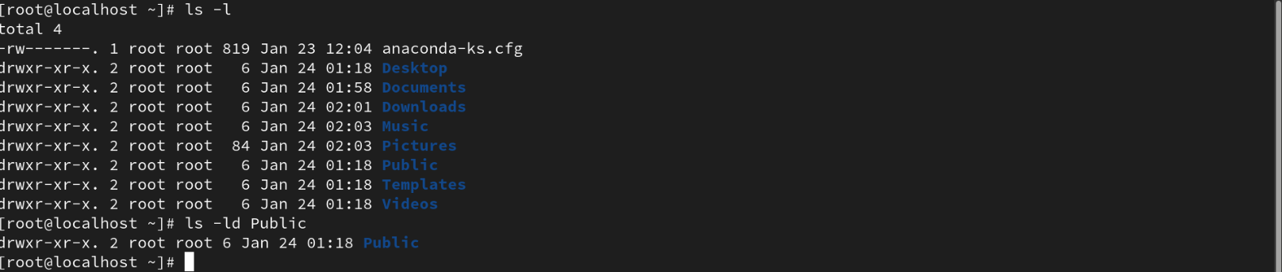

- Which Linux commands are used to view the content of files and directories? Write the commands.
The commands to view the content of files and directories are:
. ls: Lists the contents of a directory.
. cat: Displays the content of a file.
. less: Views file content one screen at a time.
. more: Similar to less but with fewer features.
. head: Shows the first few lines of a file.
. tail: Shows the last few lines of a file.

- Change your current location to the /etc/yum.repos.d directory.
    - Using the relative path method, create a file named xyz.repo under the /etc/yum.repos.d/ directory.
    - Using the absolute path method, create a file named xyz.conf under the /etc/rsyslog.d/ directory.
    - What differences did you observe between using a relative path and an absolute path?

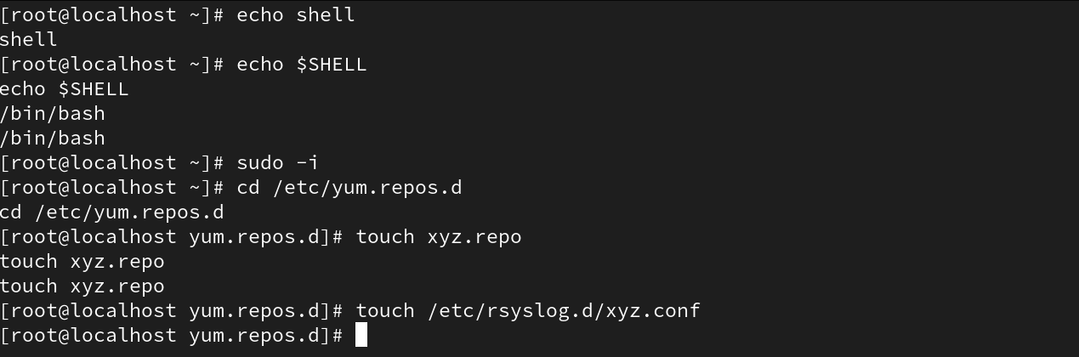
Differences Observed:
Relative Path: Refers to the current working directory, simpler and shorter command s.
Absolute Path: Specifies the full directory structure, works independently of the current directory.

- List all files, including hidden ones, in the /usr/bin/ directory with details like file permissions. Save the output to a file named output.txt in the /mnt directory. Write the command

ls -la: Lists all files, including hidden ones (-a), with detailed information (-l).

/usr/bin/: Specifies the directory to list.

> /mnt/output.txt: Redirects the output to a file named output.txt in the /mnt directory.
- Create the parent directories /Techno/Udaipur/Rajasthan/India/Asia/Earth/Solar using one command.Then, check the full structure with details in a long listing format. Write the commands. 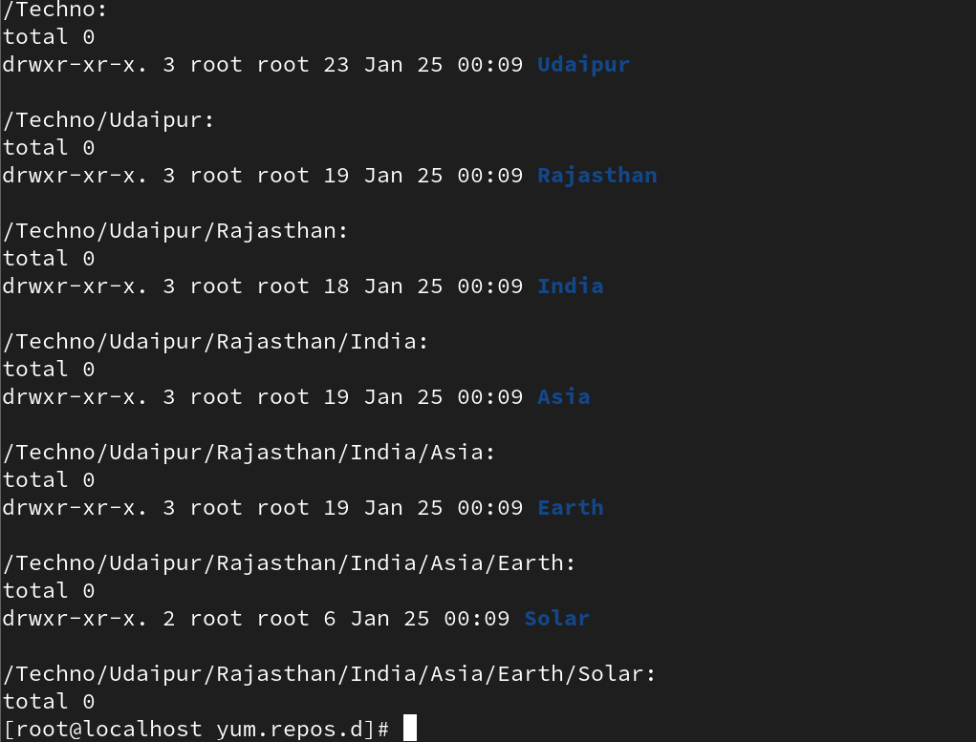

- Create a file named “Poem” under the /Techno/Udaipur/Rajasthan/ directory. Write the text "Twinkle Twinkle Little Star" into the file and save it. Perform all actions using the absolute path method.

- Delete the /Techno/Udaipur directory, including its contents, using a single Linux command. Write the command.

- How can you view the manual page for the useradd command? From the manual page, identify which files are important for user administration.(Hint: Check the 'Files' Section)
To view the manual page for the useradd command we use : man useradd command

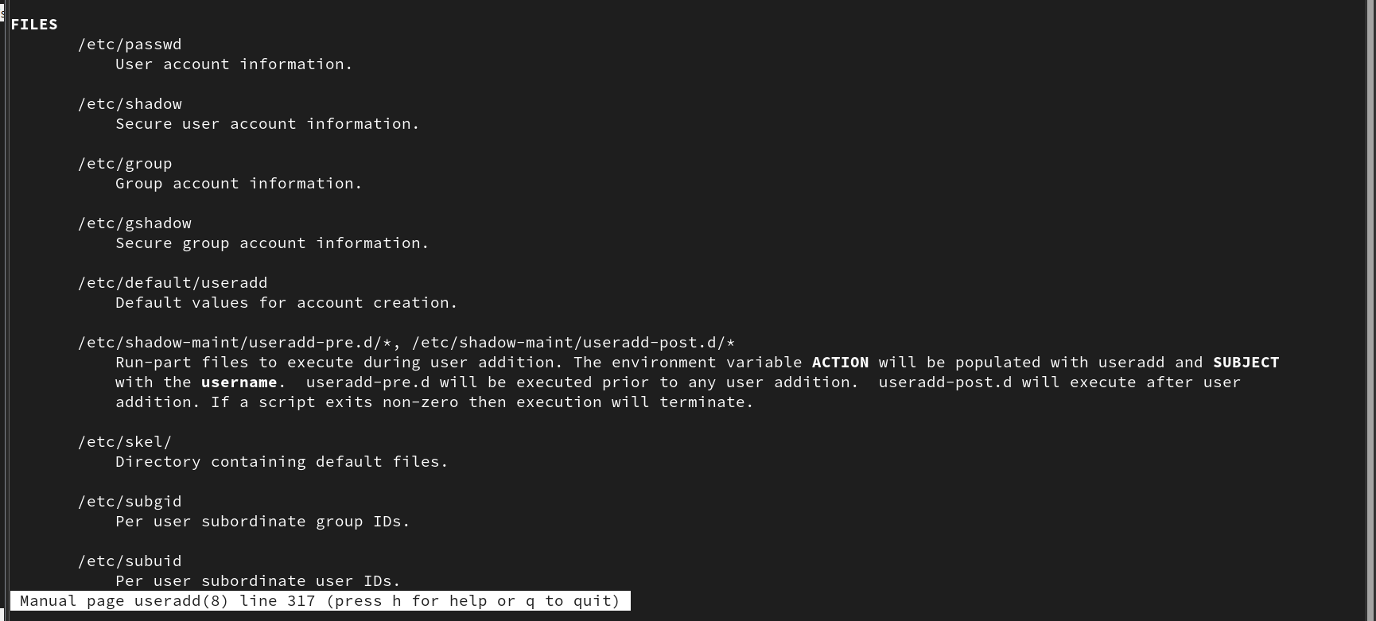

- You have two files: Fruits.txt and Vegetables.txt, each containing related content.
    - Write content in fruits.txt using vi. (EX: mango, apple, kiwi, grapes, cherry).
    - Write content in vegetables.txt using nano. (Ex: potato, tomato, onion, chilli, garlic).
    - Write the single command to Combine the contents of both files into a single file named vegetarian and display its content.
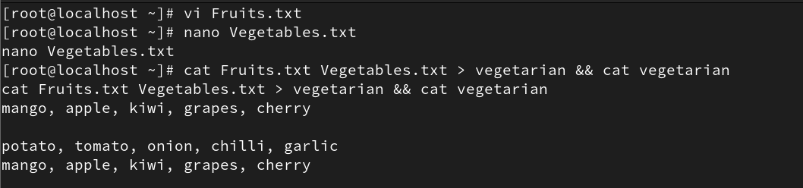

- Write the command to copy all files, including related sub-files, from /var to a new location /tmp/data/. The output should be displayed during the copying process.
To copy all files, including sub-files, from /var to /tmp/data/ and display the output during the process, use the following command:

- Rename the file “Vegetrian.txt” to “Veg.txt”. Write the command.

- Open the file “/etc/passwd and locate the following lines using less and more:
    - Search for the text "Root" using the less command.
    - Search for the word "root" using the grep command.
    - What is the use difference between more and less commands?
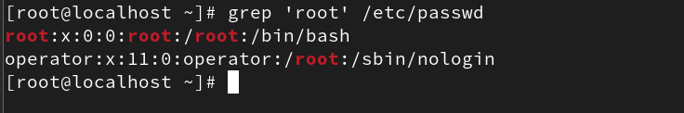
Difference between more and less commands:
- more = displays content page by page, without backward navigation.
- less = allows both forward and backward navigation, making it more flexible.

- Perform the following tasks and write the commands to achieve them:
    - Display the top 7th line of the /etc/passwd file.
    - Display the last 3 lines of the /etc/group file.
    - Display the lines 11th to 15th from the /etc/shadow file using a pipeline.
    - Display only the 16th line of the /etc/passwd file. 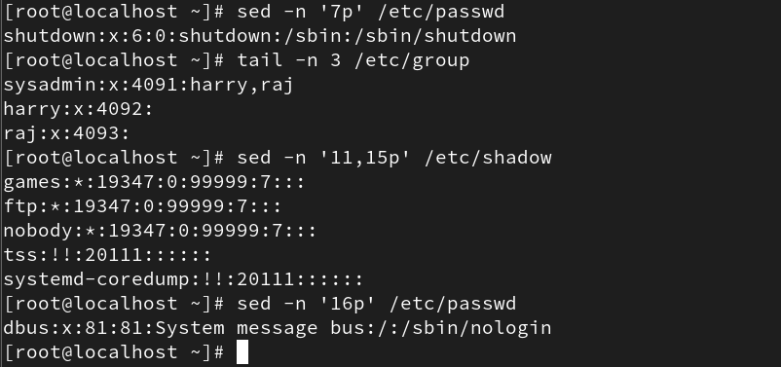

- Perform the following tasks using the grep command on the /etc/passwd file:
  - a. Write a command to match and display lines containing the word /sbin/nologin.
  - b. Write a command to match and display lines containing the multiple words (root, sbin, and /home) simultaneously, ignoring typographical case errors. Save the output for all three matches into the file /root/test. Without loosing data.
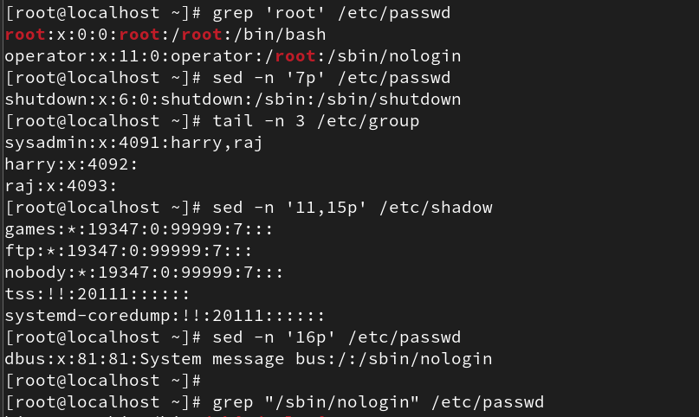

- Replace Text Using sed Linux Commands
    - Write the command to replace the word localhost with localhost.localhost in the file /etc/hosts without opening the file in an editor.
    - The /var/log/audit/audit.log file contains audit log messages, some of which include the word “success.” Write the command to count how many lines contain the word success.

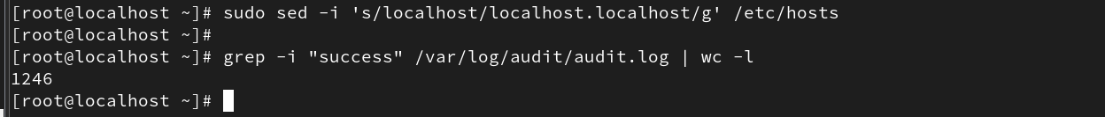

- Create a directory named “demo” on “/root”.
    - Create a file “RedHat” under the “demo” directory.
    - Run the command “vimtutor” and save the output to the “RedHat” file.
    - Now create a soft link of “RedHat” to “/etc/” location.
    - Create a hard link of /var/log/messages to /etc/log.
